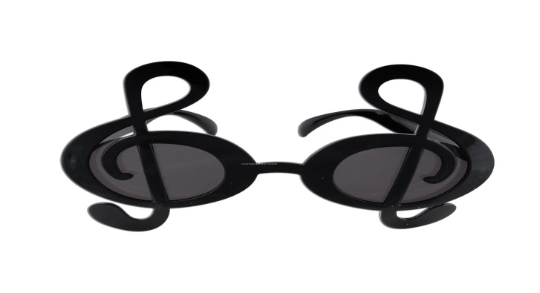

Mrs. Height’s
Classroom Handbook
2018 – 2019
Grades 2–4
“To know wisdom and instruction; to perceive the words of understanding;
To receive the instruction of wisdom, justice, and judgment, and equity;
To give subtlety to the simple, to the young man knowledge and discretion.”
Proverbs 1:2–4
Contact Info
dheight@vacsonline.org
951-242-3012 office
Mrs. Height’s Daily Schedule
Grades 2-4

Monday & Wednesday
8:00 Worship & Prayer
8:15 Bible
8:40 Math
9:50 Snack/Recess
10:10 Writers Workshop
10:35 Language Arts
12:00 Lunch
1:00 P.E. (w/ Mrs. Matthews)
1:25 Science
2:15 Readers Workshop
2:45 Mrs. Height’s Storytime (M)
Gardening (W)
3:00 Chores
3:20 Prayer and Dismissal

Tuesday & Thursday
8:00 Worship & Prayer
8:15 Bible
8:40 Math
9:50 Snack/Recess
10:10 Writers Workshop
10:35 Language Arts
12:00 Lunch
1:00 P.E. (w/ Mrs. Matthews)
1:25 Social Studies (w/ Ms. Ellenwood)
2:15 Readers Workshop
2:45 Mrs. Height’s Storytime
3:00 Chores
3:20 Prayer and Dismissal

Friday
8:00 Worship & Bible
8:20 Spelling & Memory Verse Tests
9:00 Chapel
9:30 VACS Victory Voices Choir Rehearsal
10:00 Community Gardening
10:30 Recess
11:00 S.T.E.A.M.
11:50 Clean Up, Prayer
12:00 Dismissal

CLASS CURRICULUM
BIBLE
This is the first year of our North American Division newly adopted Bible curriculum, Adventist Encounter Curriculum. The primary purpose of this curriculum is for all our students, elementary and secondary, to have a solid, deep, and personal knowledge of the truths of the Bible (Seventh-day Adventist Fundamental Beliefs); to respond to Christ’s invitation to live in a lifelong, vibrant relationship with Him; and be passionate about the salvation of others.
READING
Our literacy program, Pathways, is designed to incorporate the subjects English, Reading, Handwriting, Phonics, and Spelling easily into everyday learning. This enables the curriculum to have more fluidity and cohesiveness among the subject matter being taught.
There are nine themes that we will explore: Heroes, My World and Others, Living Things, Spiritual Journey, Friends and Family, Environment, Personal Feelings and Growth, Yesterday, and Social Issues and Culture. Each theme has a book that the class will read and discuss. In addition to the theme books, the students will be reading books and participating in activities & field trips related to the theme.
READING WORKSHOP
Reading Workshop is designed to enhance student reading skills in the areas of decoding, fluency, vocabulary, sentence construction & cohesion, reasoning, and memory/attention. During this time, students will be grouped according to reading levels and will study appropriate story selections based on running assessments. They may read in a group, with a buddy, independently, or to Mrs. Height.
WRITING WORKSHOP
Writing Workshop incorporates the English and grammar portion of our curriculum. Writing Workshops will be an avenue for students to master proper writing and language usage and will also give students the opportunity to express themselves. Journaling, letter and story writing will be major components of this experience.
GO MATH!
Go Math! is a K–8 program written specifically to support the Common Core State Standards for Mathematics with an emphasis on developing 21st-century skills. The Standards for Mathematical Practice are integrated into the content, along with an equal emphasis on conceptual fluency. The program provides rigor, depth of understanding through interactive lessons, research-based instructional approaches, best practices, English learner support, and differentiated instructional resources to ensure success for all students.

BY DESIGN
The By Design science curriculum is based on national science standards is presented in the context of the Seventh-day Adventist worldview. The four main science units are: Life Science, Human Body, Earth and Space Science, & Physical Science. Health is integrated within each unit and chapter. Within the program, each unit is broken into chapters and the chapters are broken into lessons.

CLASS POLICIES
ATTENDANCE
Regular and punctual attendance is critical for a productive learning experience. Punctuality also teaches responsibility. Each morning and afternoon a parent or guardian must sign-in when dropping off your child. If you are dropping off a late student after 8:00am, please sign-in quietly and leave any necessary notes with the sign-in book. Tardy students will be responsible for any class work missed.
In the case of an absence, a doctor’s note MUST be brought to school ON THE DAY OF THE STUDENT’S RETURN in order for the absence to be reported as excused. Classwork for excused absences will be available after school for pick up in the absence crate. The student, parent, or guardian is responsible for the pickup of missed classwork. Thank you for waiting until the end of the school day (3:20 pm) to retrieve the classwork packet. Please read the school handbook for additional information on attendance.
HOMEWORK/CLASSWORK
VACS has a “no homework” policy. However, students are HIGHLY encouraged to read for at least 30-45 minutes daily and to study their weekly spelling words and memory verses outside of the classroom.
Class work should always be completed in class. Unfinished class work will be taken home to complete and is due THE NEXT SCHOOL DAY. Recess will be lost if class work is not completed and LATE WORK WILL NOT BE ACCEPTED.
GRADES
The grading standards are as follows:
100% - 94% = A
93% - 90% = A-
89% - 87% = B+
86% - 84% = B
83% - 80% = B-
79% - 77% = C+
76% - 74% = C
73% - 70% = C-
69% - 67% = D+
66% - 64% = D
63% - 60% = D-
59% - 0% = F

*A grade of “D” or below is considered not passing in Mrs. Height’s classroom. Please always encourage your child to do his/her very best!

*In reference to report card grades, 2nd graders will receive an I (Independent), P (Progressing), or NT (Needs Time) in accordance with Southeastern California Conference education policy.

DISCIPLINE
A system of card color changes is used for behavior discipline. Every student begins the day on the color green. Each student is allowed one warning with no color change. On the second warning, their color changes to blue. On the third warning, their color changes to yellow. The fourth warning will result in a color change to orange & the fifth and final warning will result in a color change to red. If behavior continues, Principal involvement will take place. See the school handbook for additional discipline policies.
Here is a synopsis of card colors with consequences:
Green = You are having a GREAT GREEN day!
Blue = Second Warning / loss of one recess period
Yellow = Third Warning / loss of both recess periods
Orange = Fourth Warning / No recess for one week & call to parents
Red = Fifth Warning / No recess, parent conference with administration, & possible suspension
BIRTHDAYS
You are welcome to bring a small class treat on the actual day of your child’s birthday if you so desire. ARRANGEMENTS FOR ANY IN-CLASS CELEBRATION MUST BE SCHEDULED WITH MRS. HEIGHT AT LEAST ONE WEEK IN ADVANCE.
If you will be having a party at home and plan to invite the entire class, feel free to pass out invitations at school. If you are not planning to invite the entire class, I ask that you refrain from passing out invitations at school. Students’ feelings are hurt when they are not included.
PARENT VOLUNTEERS
If you would like to volunteer, please see the specifics for volunteer protocol in the VACS Parent/Student handbook. Thank you for your understanding and cooperation.
Looking forward to an exciting year filled with many successes!
God bless,
Mrs. Height

